Step1- Created a new job – named as Job 5

Steps2- attached a same Jenkins agent as we assigned to Job 4 .

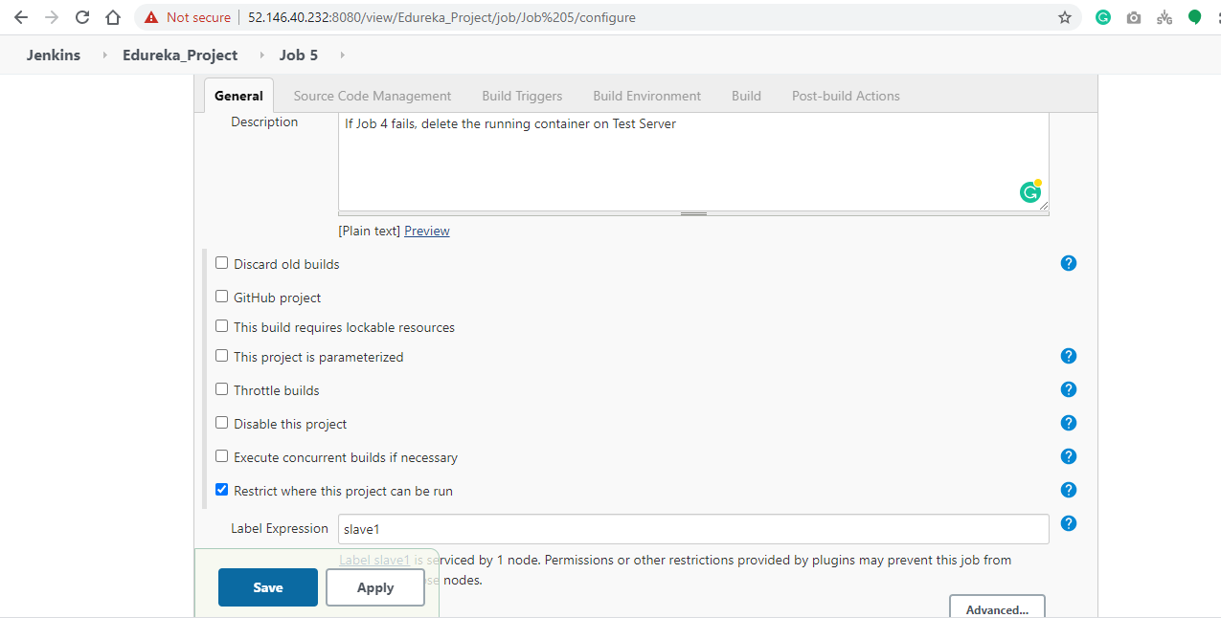

Step3-

In Build section – we have written shell script to stop the running web app container.

